Grade Four Lesson Plans Week Three (April 27-May 1, 2020)

Day One
Part One: Numeracy
Outcome(s): N11- Demonstrate an understanding of addition and subtraction of decimals N5- Describe and apply mental mathematics strategies to determine basic multiplication facts and related division facts to 9 × 9

- Math Facts Practice:
- Sign in to Sum Dog and practice your math facts for 15 minutes!

- Decimals:
- Today we learn how to add and subtract decimals. Click the link below for a quick introduction. You only need to watch part of the video so skip ahead to minute 1 and then stop at 3 minutes and 40 seconds. https://www.youtube.com/watch?v=kwh4SD1ToFc
- Next, watch this video by another teacher, who explains things a little differently https://www.youtube.com/watch?v=PnwLv6khwk8
- Try these questions from the video.
45.6 + 3.89 15 + 4.88 35.6 - 9.67 23 – 8.8
*Remember to write them down on paper in vertical columns and line up the decimals. These are the same questions from the second video, so if you get stuck, watch the video again to see the steps. Because this is practice, I will give you the answer for each question.
Answers: 49.49 19.88 25.93 14.2

Part Two: Literacy
Outcome(s): GCO 4-Students will be expected to select, read, and view with understanding a range of literature, information, media, and visual texts. GCO 8- Students will be expected to use writing and other forms of representation to explore, clarify, and reflect on their thoughts, feelings, experiences, and learnings; and to use their imaginations.

- Let’s Read!
- Click https://classroommagazines.scholastic.com/support/learnathome/grades-3-5-week-3.html
- Select Week 3 and then scroll down to Day 11. Click to read the story called Built For Thrills.
- At the bottom of the webpage you might want to check out links for a challenge activity called Marble Painting and also a game called Roller Coaster Engineer.

- Let’s Write!
- Imagine that you took a ride on the Maxx Force roller coaster. Write a story about your experience. How did you feel during the ride? What was the most exciting part? Make sure you use the words gravity and force at least once in your story.

Day Two
Part One: Numeracy
Outcome(s): N11- Demonstrate an understanding of addition and subtraction of decimals N5- Describe and apply mental mathematics strategies to determine basic multiplication facts and related division facts to 9 × 9

- Math Facts Practice:
- Sign in to Sum Dog and practice your math facts for 15 minutes!

- Decimals:
- Watch this video for a review of how to add decimals https://www.youtube.com/watch?v=Olr6KGk48BU
- Open the attached document called “decimal add w3 d2”. You can print the sheet or just copy them onto paper. Afterward, see how you did by comparing your work to the answer page that comes after the questions.

- Game Time! Open the attachment called “Strike Out” and review how to play the game. All you need is: pencil, paper and a deck of cards. Have fun!

Part Two: Literacy
Outcome(s): GCO 4-Students will be expected to select, read, and view with understanding a range of literature, information, media, and visual texts.

- Let’s Read!
- Click https://classroommagazines.scholastic.com/support/learnathome/grades-3-5-week-3.html
- Select Week 3 and then scroll down to Day 12. Click to read the story called The Search For Pirate Gold

- Word Work with Words Their Way -Open the attachment called WTW and complete these activities.
- Word Sort Preparation
- Print off your words and headings and cut them out OR write each word/heading on a small square of paper.
- Read each card, then lay out your headings.
- Sort the words using your headings. Check your work and make changes if needed.
- Mix up the words and sort again. Check your work and make changes if needed.

- Speed Sort
- Shuffle your cards and lay out the headings.
- Use a timer to see how fast you can correctly sort your cards.
- Record your finish time.
- Try two more times and record your results.
- Put your words/headings in a baggy or somewhere safe so you can use them all week.
Day Three
Part One: Numeracy
Outcome(s): N11- Demonstrate an understanding of addition and subtraction of decimals N5- Describe and apply mental mathematics strategies to determine basic multiplication facts and related division facts to 9 × 9

- Math Facts Practice:
- Sign in to Sum Dog and practice your math facts for 15 minutes!

- Decimals:
- Watch this video for a review of how to add and subtract decimals. She does a great job explaining and includes 6 examples https://www.youtube.com/watch?v=ONJneJ_Ezl4
- Open the attached document called “decimal add subtract w3 d3”. You can print the sheet or just copy them onto paper. Afterward, see how you did by comparing your work to the answer page that comes after the questions.

- Game Time! Grab a deck of cards and a partner to play Multiplication War! Shuffle the cards, place on table between partners. Each partner takes 2 cards from the deck and places them face up in front of themselves. Multiply the two numbers and say the answer out loud. The partner with highest product takes the 4 cards. All face cards are valued at 10. If partners have the same product, they declare war. Each set aside their 2 cards and flips 2 new ones. Partner with highest product takes all 8 cards. Play continues until there are no more cards and the player with the most cards wins.

Part Two: Literacy
Outcome(s): GCO 4-Students will be expected to select, read, and view with understanding a range of literature, information, media, and visual texts. GCO 8- Students will be expected to use writing and other forms of representation to explore, clarify, and reflect on their thoughts, feelings, experiences, and learnings; and to use their imaginations.

- Let’s Read!
- Click https://classroommagazines.scholastic.com/support/learnathome/grades-3-5.html
- Select Week 3 and then scroll down to Day 14. Click to read the story called Were You Fooled?
- If you haven't already, give the broomstick challenge a try.

- Let’s Write!
- Can you spot a fake? Create a how-to guide for determining whether information on the internet is reliable. Then film a video to teach others how to spot fake information online OR give a presentation to your family members about what you’ve learned.
- Write about why you think so many people were tricked by the broomstick challenge. Share your writing with someone!

Day Four
Part One: Numeracy Outcome(s): N11- Demonstrate an understanding of addition and subtraction of decimals N5- Describe and apply mental mathematics strategies to determine basic multiplication facts and related division facts to 9 × 9

- Math Facts Practice:
- Sign in to Sum Dog and practice your math facts for 15 minutes!

- Decimals:
- Watch this video for an explanation of what to do when you can’t borrow from neighboring digits https://www.youtube.com/watch?v=joF4sYmuC88 IT MIGHT BE CONFUSING AT FIRST 😊 and that’s okay; just watch it again and try working it out on paper and ask an adult to assist you if you still find it tricky. Once you’ve tried your best, just move on to the next activity…even if you haven’t been successful- it’s the effort that counts. If you run into these types of questions on the worksheets, just give it your best shot.
- Open the attached document called “decimal subtract w3 d4”. You can print the sheet or just copy them onto paper. Afterward, see how you did by comparing your work to the answer page that comes after the questions.

Part Two: Literacy Outcome(s): GCO 4-Students will be expected to select, read, and view with understanding a range of literature, information, media, and visual texts.

- Let’s Read!
- Click https://classroommagazines.scholastic.com/support/learnathome/grades-3-5-week-3.html
- Select Week 3 and then scroll down to Day 15. Click to read the story called Vernoica’s Packs (don’t forget about the Text to Speech option on the left).
- After you read, scroll to the bottom of the page and check out some of the things in the multimedia section.

- Word Work with Words Their Way
- Word Hunt
- Write your headings on a piece of paper.
- Take out your reading at home book and find words to match the headings.
- Write each word under the correct heading.
- Try to find at least 3 for each category

- Blind Sort
- Write your headings on a piece of paper.
- Ask someone to choose 10 words from your sort.
- As your partner reads the word, you write it in under the correct heading.
- When you finish, check for correct spelling and headings.
Day Five
Part One: Numeracy
Outcome(s): N11- Demonstrate an understanding of addition and subtraction of decimals N5- Describe and apply mental mathematics strategies to determine basic multiplication facts and related division facts to 9 × 9

- Math Facts Practice:
- Sign in to Sum Dog and practice your math facts for 15 minutes!

- Decimals:
- Watch this video for another explanation of how to subtract across zero https://www.youtube.com/watch?v=9PVxxiCur-E
- Open the attached document called “decimal find mistakes w3 d5”. You can print the sheet or just copy them onto paper. Afterward, see how you did by comparing your work to the answer page that comes after the questions.

- Game Time! Find a partner and play Multiplication War or Strike Out.

Part Two: Literacy
Outcome(s): GCO 4-Students will be expected to select, read, and view with understanding a range of literature, information, media, and visual texts. GCO 8- Students will be expected to use writing and other forms of representation to explore, clarify, and reflect on their thoughts, feelings, experiences, and learnings; and to use their imaginations.

- Let’s Read!
- Click https://classroommagazines.scholastic.com/support/learnathome/grades-3-5-week-3.html
- Scroll down to Day 15 and click the article called “A Titanic Treasure”.
- After reading the article, scroll to the bottom of the page and click the link to watch the “Searching for Titanic” video.

- Let’s Write!
- Take notes while you watch the video "Searching for the Titanic" below. Then write a paragraph explaining why scientists were not able to find the wreckage of the ship until 1985.
- The article and its sidebar, "Titanic Prices," describe four artifacts that were removed from the Titanic wreckage and sold at auction. Pretend you are in charge of selling one of these items. Design an advertisement that will get a buyer's attention. Be sure to give potential buyers some reasons they might want to own this piece of history.

Science
April 22, 2020 was Earth Day! This week I would love to see ways you can reuse or recycle things in or around your house. You may think that one person cannot make much of a difference but that is not true! Listen to the story One Plastic Bag that tells the story of Isatou Cessay and how she made a difference that started with one plastic bag,
Try Making your own platic purse:
https://www.youtube.com/watch?v=1zZw7yrI22M
Make a recycled plastic bag skippng rope
https://www.youtube.com/watch?v=1G_1FhW4fMQ
Or
Make plastic bag bracelets!
https://www.recyclart.org/recycled-plastic-bags-bracelets/
These are just some of the many suggestions. What can you make? Be sure to share your projects with me! Alison.bush@nbed.nb.ca

Physical Education
Physical Education is self directed at home but if you are looking for a couple of suggestions check out these! A special Thank you to Zana for sending me this great Name spelling activity!
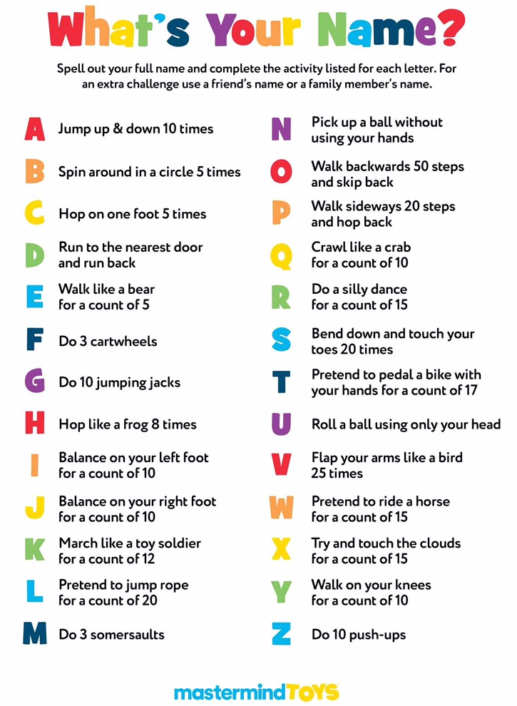 |  |  |  |  | April is also the month I start working on Jump Rope (skipping) activities! This is an excellent way to get some exercise. I am going to miss seeing students learn this skill!  For students new to the skill or struggling here is a great video of a jump rope lesson. This will help parents see how they can breakdown the steps of jump rope.  https://www.youtube.com/watch?v=n7u1gvoXdG0  For the Advance Skippers Here are some tricks!  https://www.youtube.com/watch?v=UTntXRW4wYk
 |  |  | Weekly Challenge – One hour less screen time! Do a puzzle or read! Turning off the electronics for one hour will save electicity and help our earth!
Online resources:
https://scratch.mit.edu/ or www.code.org
- Students who wish to access their account can email alison.bush@nbed.nb.ca for their login and password.
https://musiclab.chromeexperiments.com/Song-Maker/ - Make some music. Share your links with Ms. Bush!
https://www.incredibox.com/demo/ - Make beatbox rhythms on this site! A definite favourite in the older grades!
http://isleoftune.com/ - a creative music making site!

